Title of the article (Kunstler Script, 18, bold)
Academic Degree/Author's Full Name*¹ (Arabic Typesetting, 16, bold)
Affiliation, Lab, Country (Arabic Typesetting, 14, normal)
Email ……………….. Country (Arabic Typesetting, 14, normal)
Recieved … / … / …… Reviewed … / … / ……. Accepted … / … / ……
Introduction (Arabic Typesetting, 16, bold)
ملخص: (Arabic Typesetting، 14، غليظ)
ضمن هذه المساحة يجب إدراج ملخص المقال الذي لا يتجاوز في مجمل كلماته التي يحتويها 150 كلمة. ضمن هذه المساحة يجب إدراج ملخص المقال الذي لا يتجاوز في مجمل كلماته التي يحتويها 150 كلمة. ضمن هذه المساحة يجب إدراج ملخص المقال الذي لا يتجاوز في مجمل كلماته التي يحتويها 150 كلمة. ضمن هذه المساحة يجب إدراج ملخص المقال الذي لا يتجاوز في مجمل كلماته التي يحتويها 150 كلمة. ضمن هذه المساحة يجب إدراج ملخص المقال الذي لا يتجاوز في مجمل كلماته التي يحتويها 150 كلمة. ضمن هذه المساحة يجب إدراج ملخص المقال الذي لا يتجاوز في مجمل كلماته التي يحتويها 150 كلمة. ضمن هذه المساحة يجب إدراج ملخص المقال الذي لا يتجاوز في مجمل كلماته التي يحتويها 150 كلمة.
الكلمات المفتاح: (Arabic Typesetting، 14، غليظ)
كلمة مفتاح؛ كلمة مفتاح؛ كلمة مفتاح.
تصنيفات JEL:…….،….... .
"إجباري للبحوث الاقتصادية".

Abstract: (Arabic Typesetting, 14, bold)
In this box, an abstract of no more than 150 words must be included. In this box, an abstract of no more than 150 words must be included. In this box, an abstract of no more than 150 words must be included. In this box, an abstract of no more than 150 words must be included. In this box, an abstract of no more than 150 words must be included. In this box, an abstract of no more than 150 words must be included. In this box, an abstract of no more than 150 words must be included. In this box, an abstract of no more than 150 words must be included. In this box, an abstract of no more than 150 words must be included.
(Arabic Typesetting, 14, normal)
Keywords: (Arabic Typesetting, 14, bold)
Keyword; Keyword; Keyword.
JEL Classification Codes.…,……
Adding a mandatory JEL coding mode for economic studies"

Font Arabic Typesetting, size 16, line spacing 1.15, 6 pt. between paragraphs from the bottom only, justified.
In the introduction, the researcher addresses the necessary methodological elements:
- A general introduction to the topic that endeavors to explain the coordinates of the chosen title;
- Linking the topic to general and particular scientific reasons (objective, impersonal);
- Highlighting the importance and dimensions of the study;
- The nature of the topic (juristic, legal, objective, procedural, ...);
- Posing the research question clearly;
- Mentioning the division and the methodology used in answering the selected research question.
Provided that all of the latter is done with effective briefness, and in the light of the entire paper, the introduction cannot be less than one page or more than two pages.
Heading 1: ………………………. (Arabic Typesetting, 16, bold)
Font Arabic Typesetting, size 16, line spacing 1.15, 6 pt. between paragraphs from the bottom only, justified
Writing in this field has to follow the same formatting conditions and font measures mentioned in the introduction to the research.
The space in between Heading 1 and its subsequent Heading 2 contains a prelude to the research elements that are to come. The sub-titles deriving from each main title and in some cases may include definitions or information that can be included in research entrances, such as statistics, the nature of behavior or other issues and general provisions that represent an important entry for subsequent divisions.
Afterwards, Heading 1 division has to be shown into two sub-headings (as a principle).
Heading 2: ………………………. (Arabic Typesetting, 16, bold)
Font Arabic Typesetting, size 16, line spacing 1.15, 6 pt. between paragraphs from the bottom only, justified
Writing in subheadings has to follow the same formatting conditions and font measures mentioned in the introduction to the research.
Such titles include research details, textual analyzes and critical opinions, all for the purpose of answering the research question.
Heading 2: ………………………. (Arabic Typesetting, 16, bold)
Font Arabic Typesetting, size 16, line spacing 1.15, 6 pt between paragraphs from the bottom only, justified
Writing in subheadings has to follow the same formatting conditions and font measures mentioned in the introduction to the research question.
Such titles include research details, textual analyzes and critical opinions, all for the purpose of answering the research question.
Heading 1: ………………………. (Arabic Typesetting, 16, bold)
Font Arabic Typesetting, size 16, line spacing 1.15, 6 pt. between paragraphs from the bottom only, justified
Writing in this field has to follow the same formatting conditions and font measures mentioned in the introduction to the research.
The space in between Heading 1 and its subsequent Heading 2 contains a prelude to the research elements that are to come. The sub-titles deriving from each main title and in some cases may include definitions or information that can be included in research entrances, such as statistics, the nature of behavior or other issues and general provisions that represent an important entry for subsequent divisions.
Afterwards, Heading 1 division has to be shown into two sub-headings (as a principle).
Heading 2: ………………………. (Arabic Typesetting, 16, bold)
Font Arabic Typesetting, size 16, line spacing 1.15, 6 pt. between paragraphs from the bottom only, justified
Writing in subheadings has to follow the same formatting conditions and font measures mentioned in the introduction to the research.
Such titles include research details, textual analyzes and critical opinions, all for the purpose of answering the research question.
Heading 2: ………………………. (Arabic Typesetting, 16, bold)
Font Arabic Typesetting, size 16, line spacing 1.15, 6 pt. between paragraphs from the bottom only, justified
Writing in subheadings has to follow the same formatting conditions and font measures mentioned in the introduction to the research question.
Note: letters and numbers inside tables (Arabic Typesetting, 16, center)
Table 1: (Arabic Typesetting, 16, center)
Result 3 | Result 2 | Result 1 | Test/experiment
15.21 | 15.21 | 15.21 | 15.21
18.58 | 18.58 | 18.58 | 18.58
11.14 | 11.14 | 11.14 | 11.14
Table source: author(s), reference title, if available, year, p. (Arabic Typesetting, taille 16, regular)
Note: letters and numbers inside figures (Arabic Typesetting, 16, center)
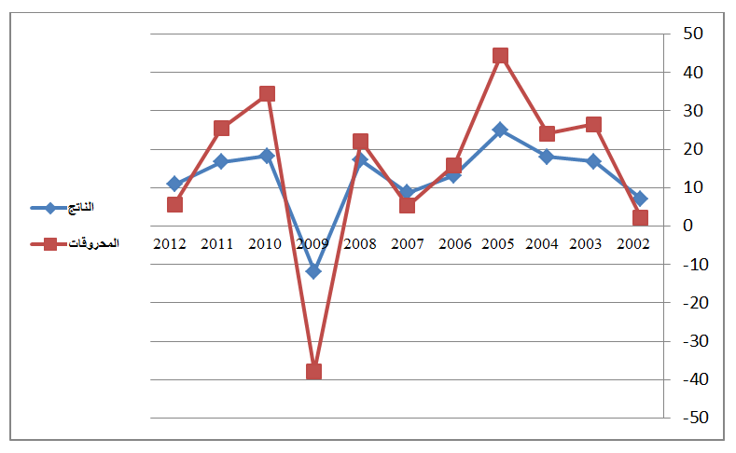
Figure 1: (Arabic Typesetting, 16, center)

Source: author(s), year, p. (Arabic Typesetting, taille 16, regular)
Note: (Figures and diagrams in image format must be “In front of the text.” The figure must be in the center of the page.
Compound charts and shapes must be grouped.
Conclusion : (Arabic Typesetting, 16, bold)
Font Arabic Typesetting, size 16, line spacing 1.15, 6 pt. between paragraphs from the bottom only, justified
The conclusion retains the same requirements as the previous research parts in terms of respecting the formatting conditions and font measures addressed in the introduction to the research.
Nonetheless:
- The research question is answered in the form of a conclusion to the article, particularly at the beginning of the conclusion;
- Right after, findings are presented and discussed.
- Clear and precise proposals are put forward.
Finally, the researcher may present a new research pathway that opens up the way to another.
Before introducing the references, the researcher may include some appendices when they are absolutely necessary and cannot be easily found outside the published article, however; It is advisable to avoid tables unless absolutely necessary, and that the table be in the middle of the page so as not to split the search between successive pages and retain the same measurements as the illustrations that the researcher may include in his article.
Referencing:
Referencing shall be as specified in the template below, provided that it:
- addresses all the information contained therein;
- comes at the end of the research.
Organizing information when citing sources, references and appendices
Font Arabic Typesetting, size 16, line spacing 1.15, 6 pt. between paragraphs from the bottom only, justified
Books: author(s), book title, publishing house, country, edition, year, page.
Theses: author, thesis title, university, college, major, year, page.
Journals: author, article title, journal name, issuer, year, volume, issue, page.
Presentations: author, title of the presentation, title of the event, nature of the scientific activity (conference, seminar...), venue, date, page.
Laws: Official Gazette, year, issue, page.
Official websites: page link, date of visit. In the case where the reference citation requires more than that; Include sufficient information, such as the author's name, article title, date of listing, date and hour of access, and other documented information for the quoted information.
Judicial decisions: issuer, date of issue, number, magazine, year, issue, page.
Appendices: The appendix information shall be mentioned as it appears on it and in the same order as it is presented, and it is followed by its number among the other appendices in the article.
Important note: Any article in which the mentioned and specific formatting guidelines are not respected will not be accepted, and it will be rejected if it does not reach 10 pages (including the introduction and conclusion only), and exceeds 20 pages (including the sources, references and appendices, if any).

. The marginal font is the same as the body font, size 14, line spacing 1, paragraph spacing 0, justified; and according to the order mentioned at the end of the template.

